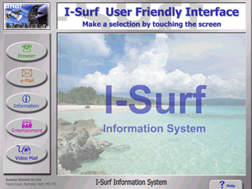

Internet Browsing and Presentation Control Software

I-Surf v6 User Interface (version 6.02)

The I-Surf User interface was designed as a user friendly control program for use with interactive touch screen kiosk systems. It is compatible with most solid state or conventional PC based kiosk systems, and will also work with some thin client solutions. As well as many additional very useful features, the software incorporates all of the most important functions required to run a standalone or kiosk network in an unattended mode of operation.

Table of Contents

Main Features 3
Requirements for use 3
Hardware 3
Software 3
Setting Up I-Surf Interface 3
User Interface Controls 4
Software 4
Payment 4
Cash 4
Account 4
Registering a PIN Number 4
Sending eMails / vMails 5
Using the Browser 5
Operator Controls 6
Modifying Displays 6
Livery Images 6
Help Messages 6
Help Icons 6
Motion Detect Parameters 7
Emergency and Customer Calls 7
Web Site Restrictions 8
On-line reporting 8
Event Logs 8
Tamper Detection 8
Using I-Surf Commands 9
Notes 10

I-Surf v6 User Interface
(Internet Browser and Presentation Control Software version 6.02)

Main Features

Customisable GUI (Graphical User Interface)
Advertising with automatic content inclusion. Full screen option
Additional concurrent Banner Advertising

Access control for local or on-line content with credit account control
Email send capabilities, including Photo mail and Video mail.
Coin / Card Payment acceptance and credit account update
Content Printing facility with control from web page.

Emergency and Customer Service Video Calls
Undesirable Site Restrictions Facility
Motion detection to activate specified media
Remote Reporting for Statistical Data Mining and Usage Tracking
Modifiable Help display Icons
Support for latest Internet content and imbedded I-Surf commands.
Local Event logging

Requirements for use

Hardware
It should run on most Pentium PC’s of a reasonable specification. Recommend minimum specification of PII 233mhz with 32mb ram; 56k Modem; 10mb Network Card; An optional Logitech Quickcam Express Camera; and any additional hardware required for chosen optional features. Suitable for use with I-Touch v23 Kiosk.

Software
Windows 95 or above; Internet Explorer 5.0 or above; Optional Logitech Quickcam drivers v6.0 or above. (call for set-up assistance with Windows XP)

Setting Up I-Surf Interface

The code has little dependencies. Simply copy or un-zip all the files into a folder called I-Surf_v6, then run loader programme ‘I-Surf_LoaderX.exe’ or the program ‘I-Surf_v6.exe’. The I-SurfBoot.log contains all initialisation event reports for each loading session.

There are also a number of other log-files to report on Cash Acceptance, Access Accounts, and Mail events and errors. These logs should be reviewed periodically.

All settings with rules are explained within the ‘I-Surf_v6.ini‘ file for ease of use. You may also use an existing
INI file from an earlier version by renaming it and adding the new parameters required for version 5. If at any time this file becomes unusable due to editing mistakes, simply delete the ‘I-Surf_v6.ini‘ and allow the Loader program to create a new default INI file. You must never delete the ‘I-Surf_Loader.ini‘ file.

User Interface Controls

On the main screen there are five buttons and a rolling demo, or advertisement displayed to the user. The functions of these five buttons are set in the INI file (as described on the previous page). They may be set to link to any Internet / Intranet site or local web page. The default URL’s are pointing to the local HTML page provided as an example.

After button selection, one of the following will occur:
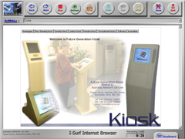

Software

The software will attempt to establish an Internet connection
if required either via the connectiod setting if specified for a
PTSN or ISDN dial up modem, or if not specified via a LAN
or other permanent connection. The browser will now
become available for the ‘Freetime’ period set.

Payment

If payment is required the user will be prompted with a code entry screen. This will require either payment in cash or a valid 18 digit code which may be entered using the on-screen keypad, or read from a valid access account card. On local browser, access is granted as above.

Cash
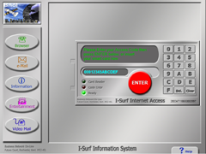
If access is granted by cash payment received, the remaining
time credit is calculated and displayed. Making additional cash
payment while browsing will increase the time credits. An
account card may not be inserted at this time.

Account
If access is granted using an on-line account code, the system
will then attempt to validate the code online. If successful, the
remaining time credit for the account will be displayed.

During browser use, the software constantly checks the
connection and updates the remaining time credit of the
user’s account.

If the user account is not allowed to expire, the user may continually increase their remaining time credits by inserting cash payments during browsing.

Registering a PIN Number

On first use of an on-line access account, it is possible for the user to specify a security Personal Identification Number (PIN) and their email address, for automatic entry when the mail facility is used. If a PIN is entered, the user will be prompted for this at the beginning of each session before use can continue.

Sending eMails / vMails

When using the send email option included in the browser by
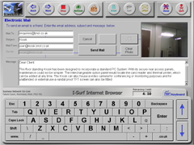
clicking on the mail button, or by clicking on an email link within
a web page, the email form will be displayed. If stored, the user’s
reply email address is automatically entered. At this stage the
user also has the option to take a snapshot of themselves or the
surroundings to send with the mail. This option can be enabled
or disabled using the ‘M’ mail setting on the button options. But
the photo option is only available if the ‘Video’ option is enabled
in the INI file.

The photo / video mail facility will create emails including the
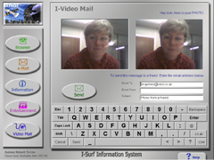
picture or video recorded. If a LAN or other permanent
connection is present, these messages are sent immediately.
Otherwise they will be stored and sent the next time that a valid
Internet connection is available via a PTSN or ISDN dial-up
modem. If the mailer encounters a problem with a message file,
the problem file is moved into the \Messages\Errors folder and
reported in the I-Surf_Mail.Log along with the reason.

Using the Browser

The browser has all the main standard buttons. The address bar functions as in any browser and maintains a history of visited sites for the individual user session. This is cleared on exit of the current browsing session.

Within the INI file the operator can specify the browser
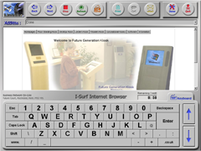
functionality for each session by enabling or disabling the
Address Bar, Keyboard, Print, Call, and Mail functions.

The on-screen keyboard can be raised and lowered using the
keyboard tab, or the embedded I-Surf commands which allows
entry of web address in the address bar and text entry on web
pages. If you experience problems with some web pages losing
focus, upgrade to IE 6.0

Upon exit, the user is presented with a completion message.
It also displays the remaining time credits if an account code
was used. Then the user is returned to the main menu screen.

Operator Controls

From within the self-explanatory ‘I-Surf_v6.ini‘ file, the operator can specify many settings, including:
- Button Functions and URL‘s or local path settings
- Button Security features (whether to dial, or ask for payment or access code).
- Browsing Restrictions to allow only authorised URL’s
- Image and Sound path Settings. All images can be customised to suit required livery
- Camera functionality. Must be set to ‘OFF’ if Quickcam drivers are not installed.
- Coin acceptance Settings (specify the coins versus time rules)
- Messages text. All user messages that appear on the help panels can be modified.

Modifying Displays

All the display image paths are specified in the INI file, and all the default images are stored as .jpg files in the folder I-Surf_v6/Images. The images can be modified as required using any reasonable quality graphics package.

From within the INI file you may also set the size and position of the main display file and banner to match your created livery. There are 5 buttons on the main display. Some or all of these buttons may be disabled by entering –1 instead of the button function codes, eg: AcrButt0=-1

Livery Images

If you modify the livery images I-Surf may report file errors and request that they are reinstalled. Don’t be alarmed, this is because I-Surf checks the integrity of all its files on load. After clicking OK to each dialogue it will continue to function correctly. However, if you wish to prevent these errors occurring on each load. You should inform Future Generation to issue new image check codes.

Help Messages

Most of the help messages that appear on the help panel can be modified to suit the intended audience. If you intend to change the messages, you must maintain the comma separated format as shown below for the system to function properly. If you don’t require an icon or audio, do not enter anything between the commas of the appropriate fields. You should always enter a title and the message text.

Message Format = [Image Path],[Audio Path],[Title],[Message Text....]

Help Icons

The help Icons are available to assist users to understand the help message. They can be located in the folder I-Surf_v6/Images/Help and may also be modified and re-saved as .jpg files.

Motion Detect Parameters

The motion detection can be used for a variety of functions. Maybe to kick-start an automatic presentation when an audience is in the vicinity, or to automatically take photos as a security feature. To enable this feature, a Logitech QuickCam camera must be installed. Then set the respective parameters in the INI file as described below.

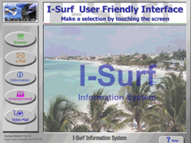
When the motion detect feature is enabled you will notice a thin

green bar just below the banner display. The bar will change
from green to red as motion is detected. The media specified will
be triggered to start when the desired percentage of motion has
been reached.

Detection display

MainActivate= (Filename : Specify the file to be displayed on screen or motion activation)
MotionDetect=ON (ON / OFF : Enable the detection feature)
MotionSense=25 (5 – 99 : Set sensitivity)
MotionShow=ON (ON / OFF : Show the detection display)

Emergency and Customer Calls

In I-Surf_v6 it’s now possible to make video conference calls, when the video feature is enabled. You will notice additional button options appearing on the help panel from the Main Display Screen. These options will allow users to make conference calls directly to a designated Customer Service or Emergency Help line with a single touch.

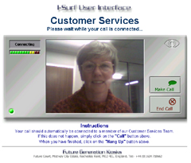
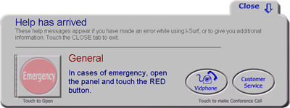

The designated IP Address can be specified in the example

pages provided. They can be modified as required and the

Section to change the IP Address is clearly commented.

I-Surf monitors when calls are in progress, and will automatically

close and return to normal operation when a call is ended

or is interrupted. It also has the benefit of being ended by

the destination if the user were to walk away and forget to

end the call.

Web Site Restrictions

On first boot, I-Surf always checks for the presence of the I-Surf_AllowedUrls.ini file. If the file is missing, the loader program will automatically create a new blank template file. This text file contains clear instructions.

If the file is left unmodified without any URL entries. No
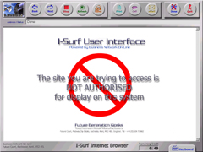

restrictions will be applied and users can visit any web

site destination when using the browser.

To restrict the browser and prevent undesirable information

being displayed, simply enter all URL’s which you have

vetted and are allowing to be viewed on your kiosk system.

When restriction is enabled, I-Surf checks every URL entered

by the user or selected from a hyperlink against the entries

found in the I-Surf_AllowedUrls.ini file, and will only grant

access to those URL’s that exist in the list. The restriction

display shown on the right, will be displayed for all non-existing

URL’s.

Further fine-tuning can be achieved by modifying the I_Surf_v6.ini file. In the button function control section, you can specify that restriction is to be lifted for any of the five main selection buttons. This is particularly useful if you wish to restrict the free access buttons but allow full access for the paid access buttons.

On-line reporting

Event Logs

On each successful load of I-Surf, the system can report its status to a central monitoring server of your choice. This is specified in the INI files. To enable the reporting feature, enter your destination URL in the update parameter as shown below.

BrowserUpdates=www.Address ( Where Address is the specified URL for collecting the report)

At the URL specified above, you should have an ASP web page available to receive the information.

report.asp (I-Surf tries to send information to www.Address/report.asp)

If you do not have a monitor server available to you, I-Surf can be configured to report to the BNOL server by setting the update parameter in the INI file to the address as shown below.

BrowserUpdates=www.kiosk.bnol.co.uk

If you are using the BNOL server to record the I-Surf boot status, you may view the status and static information on-line at : www.kiosk.bnol.co.uk/statistics

Tamper Detection
If I-Surf is running on a system fitted with the Future Generation MCI serial interface. It can be configured to detect shock or unauthorised access to the kiosk cabinet. This will also be reported on-line if the update parameter is set. Again there should be an ASP page available at the destination URL to receive data.

tamper.asp (I-Surf tries to send information to www.Address/tamper.asp )

Using I-Surf Commands

There are a number of I-Surf commands, which may be programmed into a web page and used to control functions within the I-Surf interface. For example, to automatically bring up a keyboard when a form field is clicked, you can use the command ISurfCommand:KeyboardUp as a URL.

Because I-Surf checks all URL’s either entered or hyperlinks touched before navigating, commands entered as a URL will be detected and interrupted. Listed below are the commands currently available for use with the I-Surf interface. All of the following commands should be prefixed by ISurfCommand:

- PrintNormal Sends prints to the default printer without overriding the current session settings
- PrintForce Sends prints and override the current session settings, but not the global setting
- KeyboardUp Display the on-screen keyboard with all keys enabled
- KeyboardNumLock Display the on-Screen keyboard with only the numeric keys enabled
- KeyboardNumOff Re-enable all keys on the on-screen keyboard
- KeyboardDown Hides the on-screen keyboard
- BrowserQuit Force the current browsing session to be exited

A standard web browser cannot interpret the I-Surf commands, so it would be best to direct I-Surf to dedicated kiosk pages if they include any of these commands.

When running the I-Surf Interface, you may review the example pages supplied with the program in the folder
I-Surf_v6\WebSite\I-Surf_Command to see how they interact with the interface.

Notes

(I-Surf v6 version 6.02)

- Please note that no installation is necessary, the program runs as a standalone application.

- You will be required to fit a camera to utilise the motion detection facility.

- The I-Surf_LoaderX.ini file and the Messages folder must be located in the same folder as the program. A default I-Surf_v6.ini will be created if missing.

- All time-outs and validation periods are set within the I-Surf_v6.ini file.

- If required please run concurrently with third party Web site filtering software.

- The only dependencies are Internet Explorer Version 5.0 or 6.0 and Macromedia Flash Player.

- I-Surf is a licensed piece of software, removal of any files included may cause the program to cease functioning.

- The program is exited via the help screen on the Main Menu. Click on the word “exit” and type the exit code specified in the INI, default is ‘Bye’.

If you exprience any dificulties, have any comments, or require any bespoke modifications made to suit you particular application, please contact Kiosk Support for assistance.

Future Generation Services Ltd
Future Court, Medway City Estate, Rochester, Kent. ME2 4EL

Tel: +44 (0)1634 718662 - Fax: +44 (0)1634 718646
web: www.kiosk.bnol.co.uk - e-mail: kiosk@bnol.co.uk

